AREA tw1a,CODE,READONLY

ENTRY;

MOV R0,#0X0F;

MOV R1,#0X27;

MUL R2,R0,R1;

L B L ;

END

AREA tw1b, CODE, READONLY

ENTRY

MOV R0,#10

LDR R1,=FBLOCK

LDR R2,=SBLOCK

GOTO LDRH R3,[R1],#1

STRH R3,[R2],#1

SUBS R0,#1

BNE GOTO

L B L

FBLOCK DCW 0X1234,0X5678,0X9ABC,0XDEF0,0X9876

AREA MYDATA,DATA,READWRITE

SBLOCK DCW 0

AREA tw2,CODE,READONLY

ENTRY

MOV R0,#10

MOV R4,#0000

LDR R1,=FBLOCK

LDR R2,=RESULT

LOOP LDRH R3,[R1],#2

ADD R4,R4,R3

STR R4,[R2]

SUBS R0,#1

BNE LOOP

L B L

FBLOCK DCW 0X1111,0X2222,0X3333,0X4444,0X5555,0X6666,0X7777,0X8888,0X9999,0XAAAA

AREA MYDATA,DATA,READWRITE

RESULT DCD 0

END

AREA tw3,CODE,READONLY

ENTRY

MOV R0,#6

MOV R1,R0

FACT SUBS R1,#1 ;

CMP R1,#1

BEQ L

MUL R3,R0,R1

MOV R0,R3

BNE FACT

L B L

AREA tw4,CODE,READONLY

ENTRY

MOV R6,#6; COUNT

LDR R1,=VALUE; ARRAY

LDR R8,=RESULT; RESULT MEMORY

LDR R2,[R1],#4; 1ST NO. INTO R2

LOOP LDR R4,[R1],#4 ; 2ND NO. INTO R4

CMP R2,R4 ;R2-R4

BHI LOOP1;IF R2>R4

MOV R2,R4;

LOOP1 SUBS R6,R6,#1;can also write R6,#1 ...DECREMENTING COUNTER BY 1

BNE LOOP

STR R2,[R8]

VALUE DCD 0X11111111,0X44444444,0X22222222,

0X66666666,0X33333333,0X55555555,0X88888888

L B L

AREA MYDATA,DATA,READWRITE

RESULT DCD 0

END

5. AREA tw5,CODE,READONLY

ENTRY

MOV R0,#0X80000002

MOV R1,#0X80000011

MOVS R2,R0,LSR #1

MOVS R3,R0,LSL #1

MOVS R4,R0,ASR #1

MOVS R5,R1,ROR #1

RRX R6,R0

AND R7,R0,R1

ORR R8,R0,R1

EOR R9,R0,R1

BIC R10,R0,R1

L B L

END

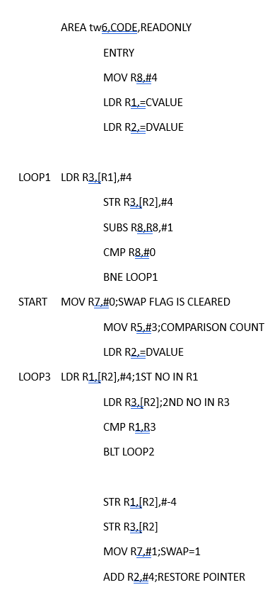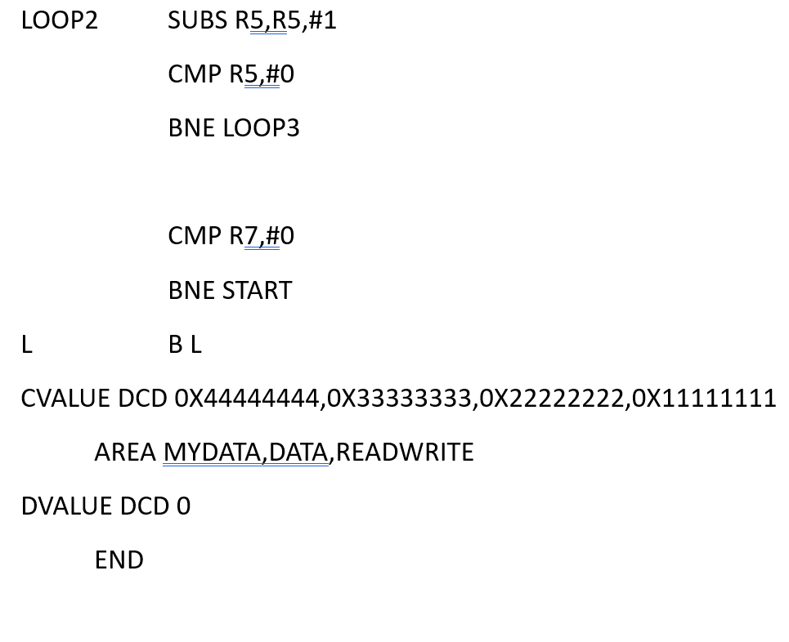

7. led arm 7

#include<LPC21xx.h>

unsigned int delay;

int main()

{

PINSEL1=0x00000000; //configure P0.16 to P0.23 as GPIO

IO0DIR=0xFFFFFFFF; //configure P0.16 to P0.23 as OUTPUT....

can also give 0x00FF0000, bcoz we r using only 16-23 pins,

make only those high(1/F)

while(1)

{

IO0SET=0x00FF0000; //set pins 16-23 of port 0(P0)

for(delay=0;delay<100000;delay++);//creates delay for 10000 msec

IO0CLR=0x00FF0000; //clears pins 16-23 of port 0(P0)

for(delay=0;delay<100000;delay++);}

}

8. Counter

#include<LPC21xx.h>

void delay(void);

unsigned int count;

int main()

{

unsigned int comp=0;

PINSEL1=0x00000000;//configure port 0(16-31) as GPIO

IO0DIR=0xFFFFFFFF;//configure P0.16 to P0.31 as OUTPUT

while(1)

{for(count=0;count<=0xFF;count++){

comp=(~count

comp=comp & 0x000000FF

IO0PIN=(comp <<16);

delay();}}

}void delay(void)

{

unsigned int i;

for(i=0;i<650;i++);

}

9. Suqare

#include<LPC21xx.h>

void delay(void);

int main()

{

PINSEL0=0X00000000; //P0.0-P0.15 AS GPIO

PINSEL1=0X00000000; //P0.16-P0.31 AS GPIO

IO0DIR=0XFFFFFFFF; //P0.0-P0.31 CONFIGURED AS OUTPUT

while(1){

IO0PIN=0x00000000;//IO0PIN IS USED TO

delay();

IO0PIN=0XFFFFFFFF;

delay();

}

}

void delay(void)

{unsigned int i;

for(i=0;i<500;i++);

}

10. Triangle

#include<LPC21xx.h>

int main()

{

unsigned long temp=0x00000000;

unsigned int i;

IO0DIR=0XFFFFFFFF; //P0.0-P0.31

while(1)

{for(i=0;i!=0xFF;i++)

{temp=i;

temp=temp<<16;

IO0PIN=temp;}

for(i=0xFF;i!=0;i--)

{

temp=i;

temp=temp<<16;

IO0PIN=temp;

}

}

}

11.Relay

#include <LPC21xx.h>

unsigned int i;

int main()

{

IO0DIR=0x00000600; //set P0.10 as output

IO0SET=0x00000600; //P0.10-for relay and P0.09 for buzzer is set to HIGH...turning on the relay

while(1)

{

for(i=0;i<1000000;i++);

IO0SET=0x00000600; //relay on

for(i=0;i<1000000;i++);

IO0CLR=0x00000600; //relay off

}

}

12. Arduino Led

// the setup function runs once when you press reset or power the board

void setup() {

// initialize digital pin LED_BUILTIN as an output.

pinMode(LED_BUILTIN, OUTPUT);

}

// the loop function runs over and over again forever

void loop() {

digitalWrite(LED_BUILTIN, HIGH); // turn the LED on (HIGH is the voltage level)

delay(100); // wait for a second

digitalWrite(LED_BUILTIN, LOW); // turn the LED off by making the voltage LOW

delay(100); // wait for a second

}

13.LDR

//RM3 to RM20

int light_pin=5;

void setup() {

// put your setup code here, to run once:

pinMode(light_pin,INPUT);

Serial.begin(9600);

}

void loop() {

int light_data=digitalRead(light_pin);

if(light_data==1)

{

Serial.println("Light not detected!");

}

else

{

Serial.println("Light detected!");

}

delay(1000);

}

14.Buzzer

//buzzer pgm

//RM17-RM9

int buzzer_pin=9;

void setup() {

// put your setup code here, to run once:

pinMode(buzzer_pin,OUTPUT);

Serial.begin(9600);

digitalWrite(buzzer_pin,HIGH);

}

void loop() {

// put your main code here, to run repeatedly:

digitalWrite(buzzer_pin,LOW);

Serial.println("Buzzer is ON");

delay(1000);

digitalWrite(buzzer_pin,HIGH);

Serial.println("Buzzer is OFF");

delay(1000);

}